**Section___________________________ Holocaust WebQuest**

**Introduction**

The Holocaust was a terrible and tragic time in modern history during which millions of people were systematically destroyed by Adolf Hitler and his Nazi regime. These people were targeted by the because of their beliefs, background, heritage, and/or their lifestyle.  
  
We are studying the Holocaust to remember the horror and destruction that evil will do when given the opportunity.  
  
We will be looking at the Holocaust for the next few weeks and this WebQuest will help provide you with essential background knowledge for other texts that we will be reading, including The Diary of Anne Frank (play version) and Four Perfect Pebbles, by Lila Perl and Marion Blumenthal Lazan.

**The Task**

Your task is to explore the websites on each page so that you may better understand the events and people that led to the rise of Adolf Hitler and Nazism. You will also discover what exactly the Holocaust was and those whom it affected, then and now.

**The Process**

Beginning with "Germany-Post World War I" at the top of the navigation bar on the left, make your way down through this site's pages, following the directions in yellow and  exploring other websites by clicking on the orange links.   
  
  
Although some pages only have one website to visit, other pages have more than one. Please visit all links and answer all questions in your note packet fully and in complete sentences.

**Evaluation**

This WebQuest will be evaluated based on the quality and completeness of the answers in your companion note packet.   
  
You will also be graded on the test that follows the completion of the WebQuest.

**Conclusion**

As a result of your research into Adolf Hitler, Nazi Germany and the Holocaust, you have reviewed a large amount of information relating to the Holocaust and the time period surrounding it.    
  
It is important to learn about atrocities like the Holocaust and to educate those who come after us so that we do not repeat the mistakes of past generations. Completing this WebQuest is a step in that direction.

**Germany Post-World War I**

[**http://www.schoolshistory.org.uk/ASLevel_History/week3_impactofwar.htm**](http://www.schoolshistory.org.uk/ASLevel_History/week3_impactofwar.htm)

**What were the social consequences of World War I for Germany?**

**What were the economic consequences of World War I for Germany?**

**What political changes occurred in Germany after World War I?**

**During World War I, Germany lost an estimated 1.7 million young men.**

**How do you think this affected the country of Germany?**

**Germany Post-World War I Continued**

[**http://www.schoolshistory.org.uk/ASLevel_History/week4_versailles.htm**](http://www.schoolshistory.org.uk/ASLevel_History/week4_versailles.htm)

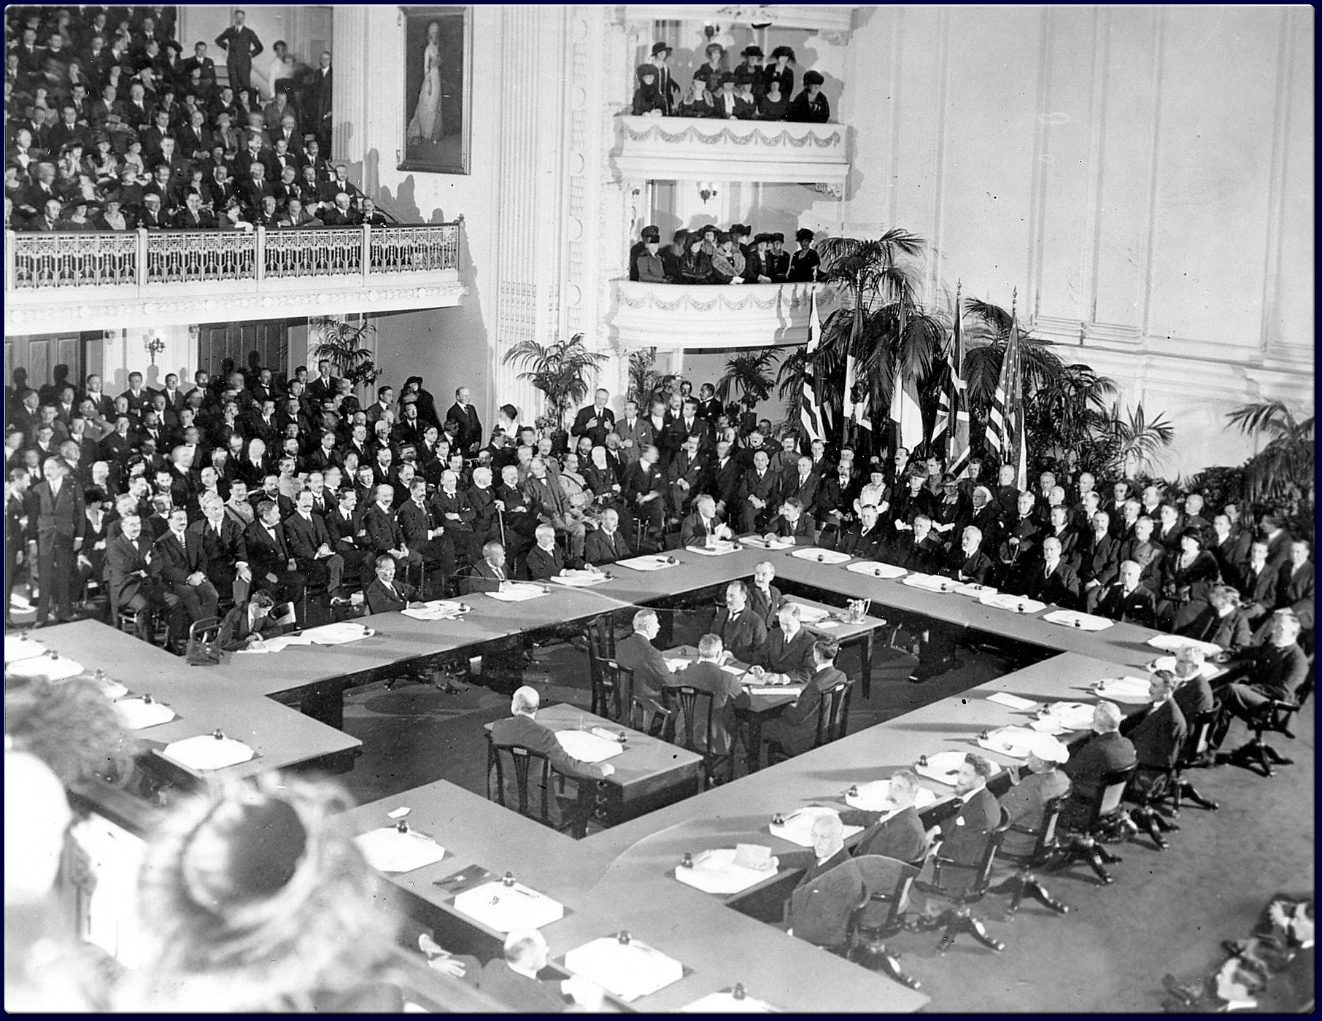

**Discuss some of the negative repercussions that the Treaty of Versailles had on Germany.**

**Anti-Semitism**

[**http://www.adl.org/hate-patrol/antisemitism.asp**](http://www.adl.org/hate-patrol/antisemitism.asp)

**What is anti-Semitism?**

**How did the horrors of the Holocaust originate from this prejudice?**

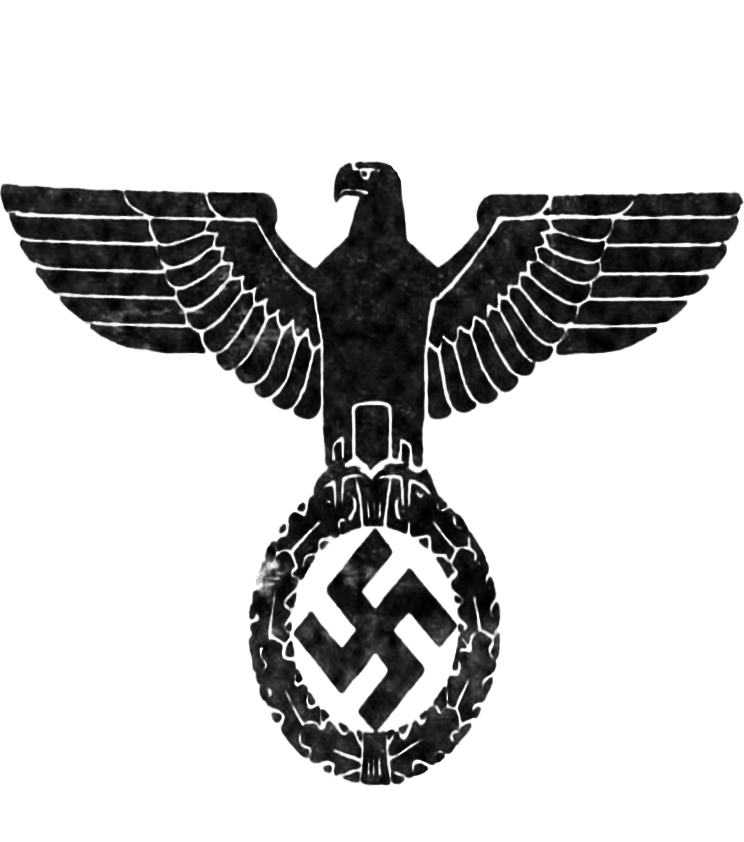**Rise of Nazism/Racial Theories of Nazis/Anti-Jewish Policies**

**(Read page 47-50)**

[**http://www.friends-partners.org/partners/beyond-the-pale/english/47.html**](http://www.friends-partners.org/partners/beyond-the-pale/english/47.html)

**According to this website, what factors contributed to make**

**the horrific events of the Holocaust possible?**

**Why did the political, economic, and social state of Germany after World War I**

**allow Hitler to gain such extensive political power?**

**Describe the racial theories of the Nazis.**



**Throughout history, has any other group or groups had similar theories about race?**

**Give one example.**

**List several anti-Jew policies set in place by the Nazis.**

**How did these policies serve weaken the Jewish population of Germany?**

**Adolf’s Rise to Power**

[**http://www.time.com/time/photogallery/0,29307,1707887,00.html**](http://www.time.com/time/photogallery/0,29307,1707887,00.html)

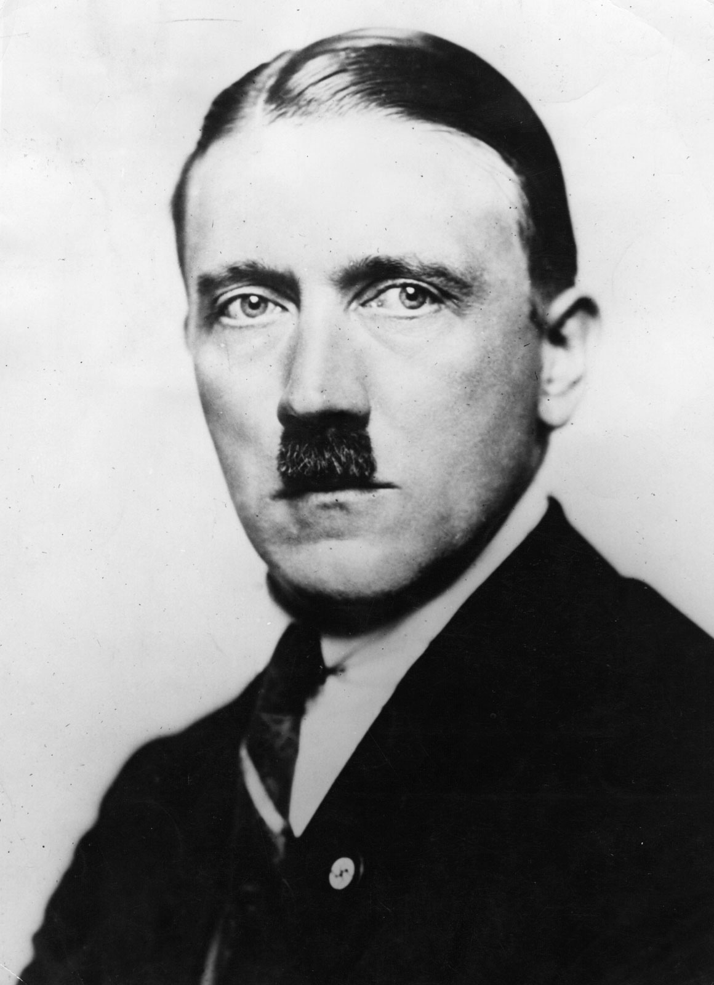

**What characteristics and talents made Adolf Hitler a popular leader?**

**How did Adolf Hitler gain control of the German military?**

**Nazi Propaganda**

[**http://www.calvin.edu/academic/cas/gpa/posters2.htm**](http://www.calvin.edu/academic/cas/gpa/posters2.htm)

**The Nazis used propaganda to successfully win over millions of followers. Define propaganda.**

**Look through the examples of Nazi propaganda. You may want to skim all the way through.**

**Find *two* posters that you find especially interesting.**

**Print out a small copy of each poster and tape them into your packet here.**

**Look at each of your selections. What is the overall message behind the poster?**

**How did the Nazis draw upon the emotions of the viewer? The logic and intelligence of the viewer?**

**How did the poster portray Nazis? German citizens? Jewish individuals?**

**Third Reich and Nazi State**

[**http://www.jewishvirtuallibrary.org/jsource/Holocaust/police.html**](http://www.jewishvirtuallibrary.org/jsource/Holocaust/police.html)

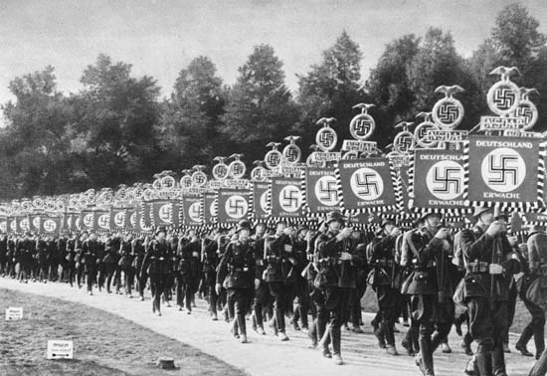**Although the police originally had doubts about the Nazi party, they were soon won over my Hitler and his regime. List three of the ways that Hitler gained the support of the police.**

**Why did Hitler put forth such effort in winning over the police force?**

**Over time the police became fused with Nazi SS and SD.**

**How were these two forces different from the traditional police force?**

**How did the SS and the SD assist Hitler with his evil plans?**

**The Final Solution**

[**http://www.ushmm.org/wlc/en/article.php?ModuleId=10007328**](http://www.ushmm.org/wlc/en/article.php?ModuleId=10007328)

**The “Final Solution” describes Hitler’s master plan to eliminate all of the Jews from Germany. This process**

**took place over several steps. One of the first steps was to place Jews and other “non-Aryans” into ghettos.**

**How would this movement help further his plan?**

**Nazis began killing off entire populations of Jewish people.**

**Why do you think these acts were tolerated? Why didn’t anyone speak up?**

**Kristallnacht**

[**http://www.historyplace.com/worldwar2/holocaust/h-knacht.htm**](http://www.historyplace.com/worldwar2/holocaust/h-knacht.htm)

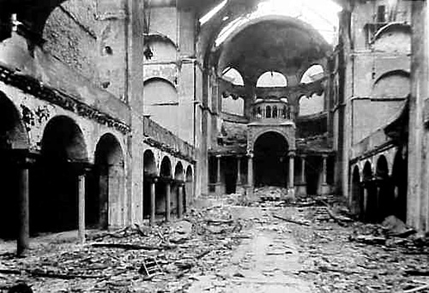

**What does the name “Kristallnacht” stand for? Why is this name an appropriate name for this night?**

**Adolf Hitler had been in power for several years prior to this attack on the Jews.**

**Why did he decide to make this direct attack now?**

**Describe the extent of the destruction that occurred during the Kristallnacht.**

**How do you react to the quote at the end of the page?**

**Synagogues**

[**http://fcit.coedu.usf.edu/holocaust/timeline/KMap.htm**](http://fcit.coedu.usf.edu/holocaust/timeline/KMap.htm)

**What is a synagogue? What is the significance of setting these particular buildings on fire?**

**The Star of David**

[**http://www.jewishvirtuallibrary.org/jsource/Holocaust/badges.html**](http://www.jewishvirtuallibrary.org/jsource/Holocaust/badges.html)

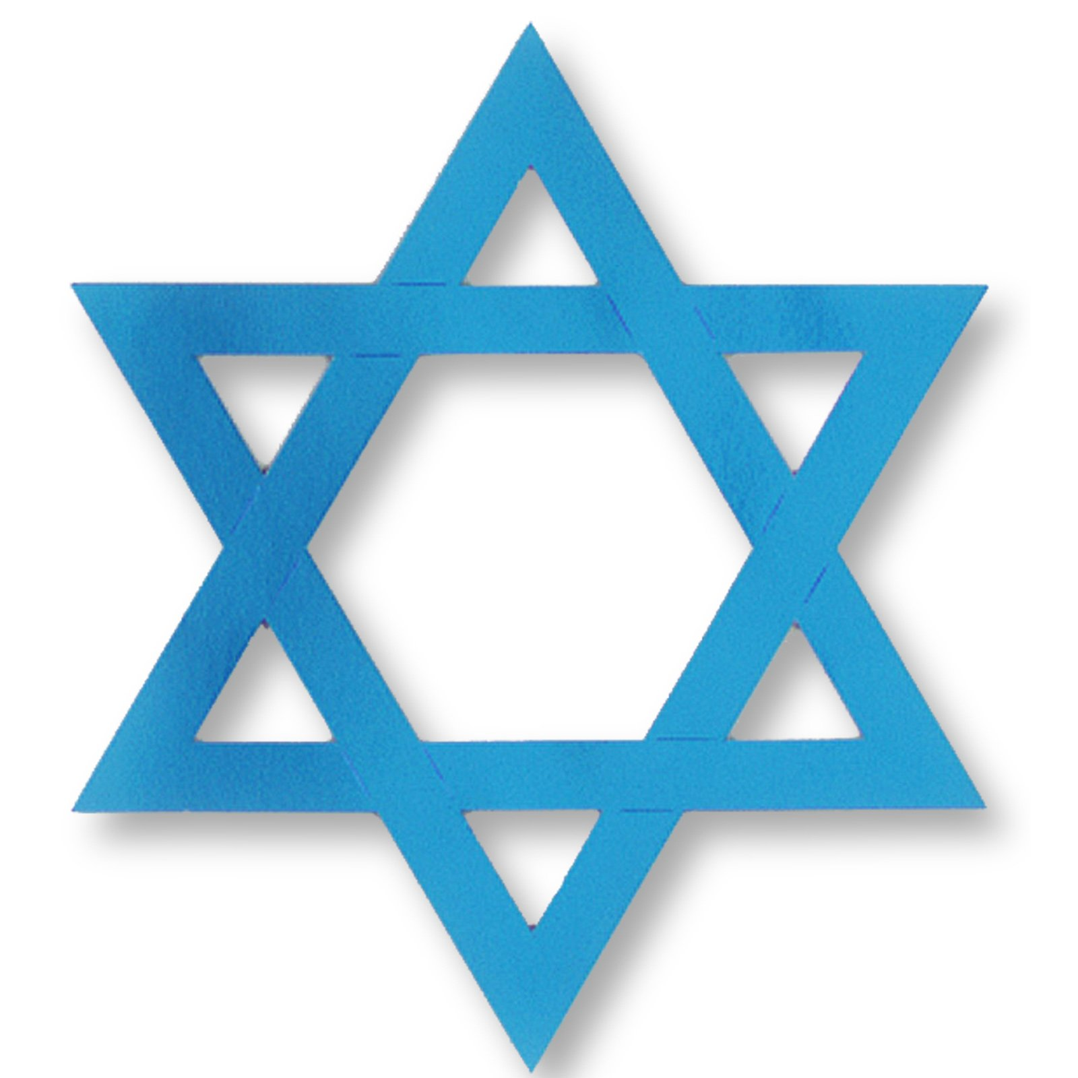

**The Star of David is a symbol used to represent Judaism. It is usually meant as a symbol of pride and religious devotion. Was this the intention of the Nazis? Why? What did the Star of David symbolize to the Nazis?**

**Why did the Nazis force Jewish men, women, and children to wear the yellow Star of David on their clothing?**

**What was the penalty for not wearing the yellow star?**

**Describe other measures that were included in the “special treatment” of the Jews.**

**Treatment of the Jews**

**Auschwitz**

[**http://www.holocaust-trc.org/wmp17.htm**](http://www.holocaust-trc.org/wmp17.htm)

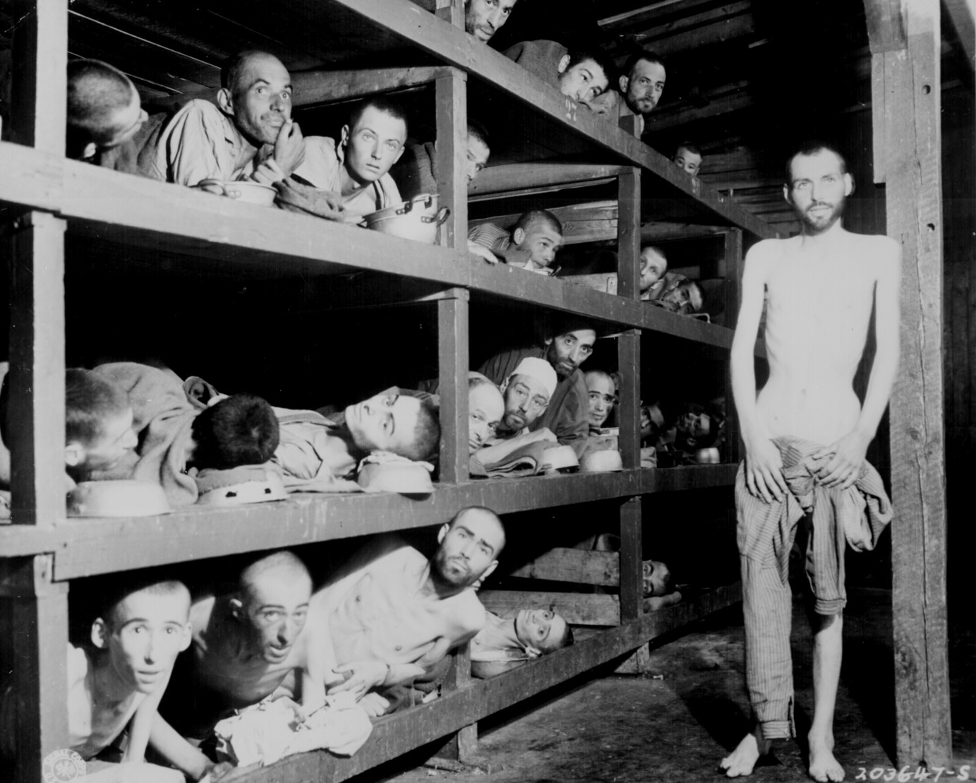**What was the phrase written above the entrance of Auschwitz?**

**What is ironic about this phrase?**

**Besides the SS guards, who else was involved in the extermination of the prisoners?**

**Why was roll call such a prevalent activity at Auschwitz?**

**Concentration Camp Photographs**

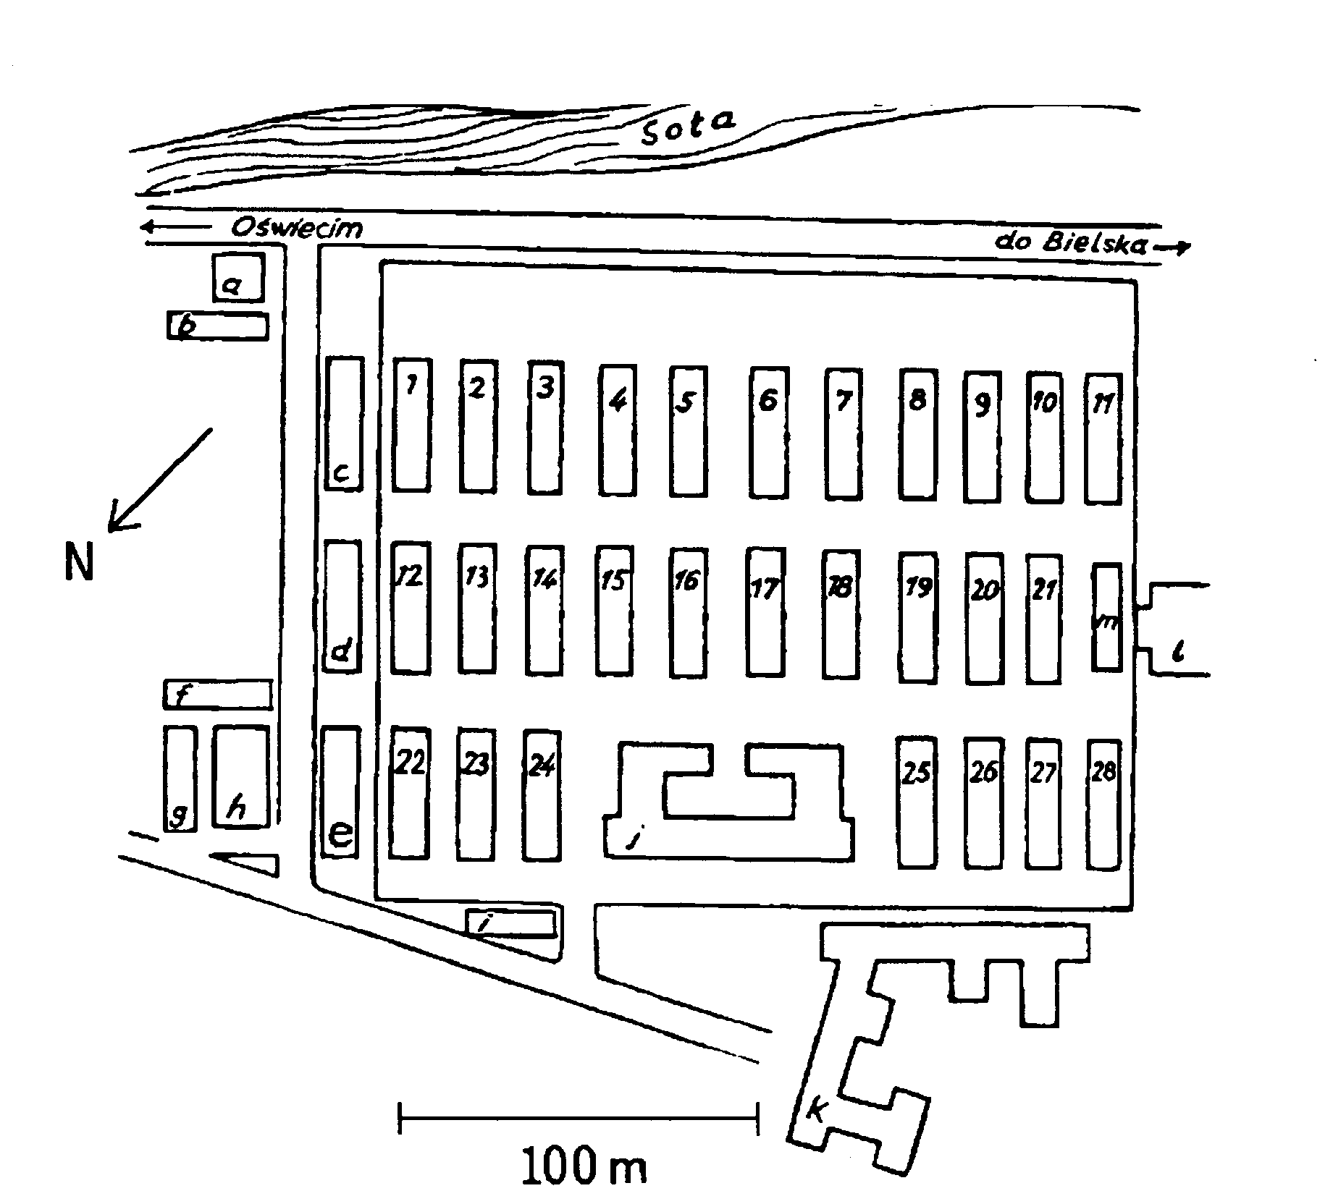[**http://www.remember.org/educate/fotolist.html**](http://www.remember.org/educate/fotolist.html)

**Describe the overall atmosphere of the photographs.**

**Virtual Tour**

[**http://www.remember.org/camps/**](http://www.remember.org/camps/)

**Explore on of the interactive maps of the concentration camps.**

**Describe at least one photograph that stuck out to you.**

**Death Camps**

[**http://www.deathcamps.info/index.htm**](http://www.deathcamps.info/index.htm)

**What are the names of the six death camps that the Nazis established?**

1. **_____________________**
2. **_____________________**
3. **_____________________**
4. **_____________________**
5. **_____________________**
6. **_____________________**

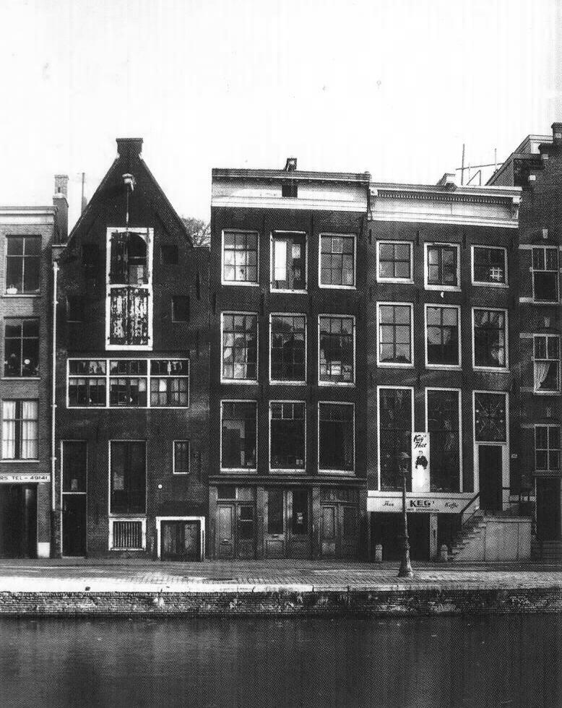

**Anne Frank**

**Virtual Tour of the Attic**

[**http://www.annefrank.org/**](http://www.annefrank.org/)

**Who helped the families while they were in hiding?**

**What were the consequences if they were caught?**

**Why do you think they were willing to help out Jewish families?**

**Survivor Stories**

[**http://www.holocaustsurvivors.org/survivors.php**](http://www.holocaustsurvivors.org/survivors.php)

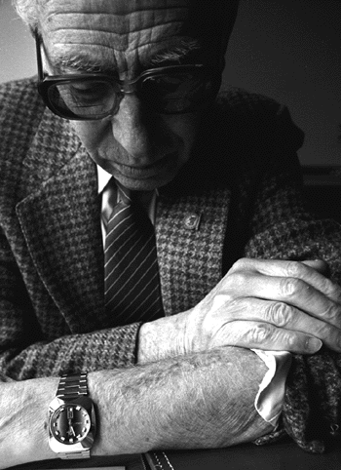

**Choose one survivor story to read in its entirety.**

**Describe the situation that your survivor had to endure.**

**Can you relate to any aspect of your survivor’s life before, during, and/or after World War II?**

**(Maybe you shared a common interest, family life, or were the same age.)**

**What was your reaction to your survivor’s story? Did anything surprise you? Upset you?**